Test-Driven Development (TDD)

What is Test-Driven Development (TDD)
# Source: AI Source: Provided by: [Data Path: Persons Table -> ID Column: 1, Name_En Column: Motasem Essam] -> From: [Chatgpt (GPT‑5 Mini)] on [8/24/2025]
Test-Driven Development (TDD) is a software development approach where developers write tests before writing the actual code.
👉 The main idea:
“Write a failing test first → Write just enough code to make it pass → Refactor → Repeat.”

🔄 TDD Cycle (Red–Green–Refactor)
# Source: AI Source: Provided by: [Data Path: Persons Table -> ID Column: 1, Name_En Column: Motasem Essam] -> From: [Chatgpt (GPT‑5 Mini)] on [8/24/2025]
- Red 🔴 – Write a failing test for a small piece of functionality.
  - The test fails because the feature doesn’t exist yet.
- Green 🟢 – Write the minimum code needed to make the test pass.
  - Don’t over-engineer, just solve the failing test.
- Refactor 🔁 – Clean up the code while keeping tests passing.
  - Improves readability, removes duplication, optimizes design.
Then repeat for the next piece of functionality.

🛠️ Example (Simple Login Check)
# Source: AI Source: Provided by: [Data Path: Persons Table -> ID Column: 1, Name_En Column: Motasem Essam] -> From: [Chatgpt (GPT‑5 Mini)] on [8/24/2025]

- Step 1 (Red): Write a test
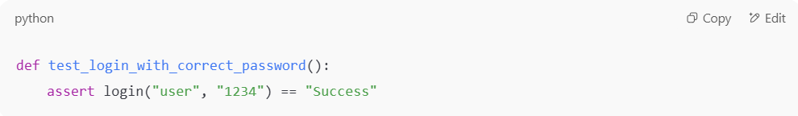
def test_login_with_correct_password():
assert login("user", "1234") == "Success"

- Step 2 (Green): Write just enough code
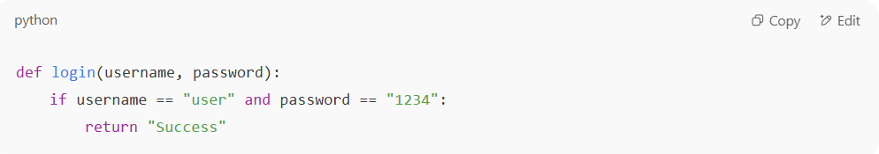
def login(username, password):
if username == "user" and password == "1234":
return "Success"

- Step 3 (Refactor): Improve code (e.g., make it flexible, use DB, etc.) while keeping test passing.

📊 Benefits of TDD
# Source: AI Source: Provided by: [Data Path: Persons Table -> ID Column: 1, Name_En Column: Motasem Essam] -> From: [Chatgpt (GPT‑5 Mini)] on [8/24/2025]
- ✅ Leads to cleaner, modular, and testable code
- ✅ Catches bugs early
- ✅ Provides living documentation (tests describe behavior)
- ✅ Reduces debugging time
- ✅ Increases confidence in changes (regression safety)

⚠️ Challenges
# Source: AI Source: Provided by: [Data Path: Persons Table -> ID Column: 1, Name_En Column: Motasem Essam] -> From: [Chatgpt (GPT‑5 Mini)] on [8/24/2025]
- ⏱️ Initial development may feel slower
- Requires discipline to always follow Red–Green–Refactor
- Not ideal for exploratory or UI-heavy features

IS Test-Driven Development (TDD) IS TYPE OF Collaboration-Based Approaches
# Source: AI Source: Provided by: [Data Path: Persons Table -> ID Column: 1, Name_En Column: Motasem Essam] -> From: [Chatgpt (GPT‑5 Mini)] on [8/24/2025]
Yes 👍 you’ve got it — Test-Driven Development (TDD) is considered one of the Collaboration-Based Approaches to testing.
Let me clarify with context:

🟢 Collaboration-Based Approaches (Overview)
# Source: AI Source: Provided by: [Data Path: Persons Table -> ID Column: 1, Name_En Column: Motasem Essam] -> From: [Chatgpt (GPT‑5 Mini)] on [8/24/2025]
These approaches emphasize team collaboration (developers, testers, product owners, business stakeholders) to build a shared understanding of requirements and quality before and during development.

🔑 Main Types of Collaboration-Based Approaches
# Source: AI Source: Provided by: [Data Path: Persons Table -> ID Column: 1, Name_En Column: Motasem Essam] -> From: [Chatgpt (GPT‑5 Mini)] on [8/24/2025]
- Test-Driven Development (TDD)
  - Developers write unit tests first, then code.
  - Collaboration mainly between developers & testers.
  - Focus: building correct code at the lowest level.
- Behavior-Driven Development (BDD)
  - Builds on TDD but uses natural language scenarios (Given–When–Then).
  - Collaboration between business, testers, and developers.
  - Focus: ensuring the system behaves as expected from a user/business perspective.
- Acceptance Test-Driven Development (ATDD)
  - Similar to BDD, but acceptance criteria/tests are defined before coding.
  - Collaboration between customers/product owners, testers, developers.
  - Focus: acceptance of features by stakeholders.
- Specification by Example (SbE)
  - Requirements are captured as concrete examples.
  - These examples double as tests and living documentation.
  - Strong collaboration across the whole team.
- Exploratory Testing (Collaborative Form)
  - Done in pairs or groups (e.g., “mob testing” sessions).
  - Encourages shared learning and fast feedback.
  - Focus: discovering unknown risks through exploration.

⚖️ Final Answer
# Source: AI Source: Provided by: [Data Path: Persons Table -> ID Column: 1, Name_En Column: Motasem Essam] -> From: [Chatgpt (GPT‑5 Mini)] on [8/24/2025]
✅ TDD is a type of Collaboration-Based Approach, alongside BDD, ATDD, Specification by Example, and Collaborative Exploratory Testing.
- TDD → more developer-focused
- BDD/ATDD/SbE → business + tester + developer collaboration
- Exploratory (collaborative) → whole team discovery

⚖️ Final Definition
# Source: AI Source: Provided by: [Data Path: Persons Table -> ID Column: 1, Name_En Column: Motasem Essam] -> From: [Chatgpt (GPT‑5 Mini)] on [8/24/2025]
TDD (Test-Driven Development) is a development practice where tests are written first, guiding the creation of production code in small, iterative Red–Green–Refactor cycles to ensure correctness, simplicity, and maintainability.

